Synopsis

Loan Default Prediction using Machine Learning
Problem Id: 2

Krishna Mandal
2028447
Section-L

Mansha Khati
2028452
Section-L

Samriddhi Agarwal
2028482
Section-L

\

- Problem Description
In the banking sector, one of the major challenges is deciding whether a customer is likely to repay a loan or not. Financial institutions deal with large volumes of loan applications, and even a small percentage of wrong decisions can result in significant losses. Because of this, there is a strong need for a system that can assist in identifying risky customers before approving loans.
In this project, we aim to build a machine learning-based classification system using a real-world loan dataset (such as Lending Club data). The dataset contains various customer and loan-related features such as loan amount, interest rate, employment details, credit history, and repayment behavior. These features provide useful information about the financial condition of a borrower.
The goal of this project is to analyze these features and develop a model that can classify whether a loan will be fully paid or defaulted. This system can help banks in reducing risk, improving decision-making speed, and making the loan approval process more reliable.

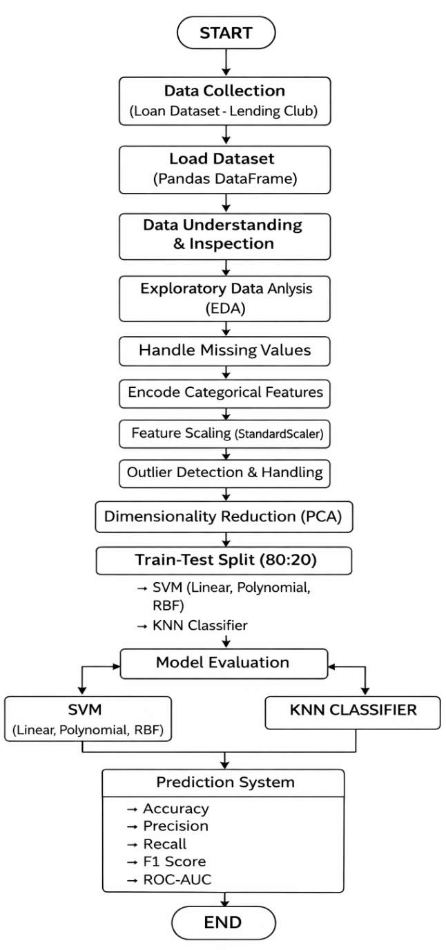
- Steps of Implementation (ML Pipeline)

1.data collection
Feature Name | Description | Data Type
loan_amnt | Amount of loan applied by customer | Numerical (int)
funded_amnt | Amount funded by lender | Numerical (int)
term | Loan duration (36 or 60 months) | Categorical
int_rate | Interest rate of loan | Numerical (float)
installment | Monthly payment amount | Numerical (float)
grade | Loan grade assigned by company | Categorical
sub_grade | Sub category of loan grade | Categorical
emp_title | Job title of borrower | Categorical
emp_length | Employment duration | Categorical
home_ownership | Ownership status (Rent/Mortgage/Own) | Categorical
annual_inc | Annual income of borrower | Numerical (float)
verification_status | Income verification status | Categorical
loan_status | Target variable (Default / Fully Paid) | Categorical
purpose | Purpose of loan | Categorical
dti | Debt-to-income ratio | Numerical (float)
delinq_2yrs | Number of delinquencies in last 2 years | Numerical (int)
fico_range_low | Lower range of FICO score | Numerical (int)
fico_range_high | Upper range of FICO score | Numerical (int)
open_acc | Number of open credit accounts | Numerical (int)
pub_rec | Number of public records | Numerical (int)

The dataset is collected from a reliable source such as Lending Club or Kaggle. It contains multiple features related to loan applications and borrower profiles. The dataset includes both input features and the target variable (loan status).

2. Loading Dataset
The dataset is loaded using the Pandas library into a DataFrame. Basic inspection is done to understand the structure of the dataset, including checking column names, data types, and sample values. This step helps in identifying potential issues in the data.

3. Exploratory Data Analysis (EDA)
EDA is performed to understand patterns and relationships in the data. Visualizations such as histograms and boxplots are used to study the distribution of variables like loan amount and income. Correlation heatmaps help in identifying which features are strongly related to loan default.

4. Data Preprocessing
Data preprocessing is necessary to clean and transform the dataset before applying machine learning models.
- Handling Missing Values
Missing values are detected and handled using methods such as filling with mean, median, or mode. This ensures the dataset is complete and usable.
- Encoding Categorical Features
Features such as employment type, home ownership, and loan purpose are converted into numerical form using encoding techniques like One-Hot Encoding or Label Encoding.
- Feature Scaling
Numerical features such as loan amount, income, and interest rate are scaled using StandardScaler. This ensures that all features have similar ranges.
- Outlier Handling
Extreme values are identified using visualization techniques and handled to prevent them from affecting model performance.

5. Dimensionality Reduction (PCA)
Principal Component Analysis (PCA) is applied to reduce the number of features while preserving important information. This helps in improving model efficiency and reducing computational complexity.

6. Train-Test Split
The dataset is divided into training and testing sets, typically in an 80:20 ratio. The model is trained on the training data and tested on unseen data to evaluate its performance.

7. Model Training
Different classification algorithms are used for training the model. Support Vector Machine (SVM) is applied with different kernels such as linear, polynomial, and RBF. K-Nearest Neighbors (KNN) is also used for comparison.

8. Model Evaluation
The performance of the models is evaluated using metrics such as accuracy, precision, recall, and F1-score. ROC-AUC is also used to measure the overall classification performance.

9. Result Analysis
All models are compared based on their performance metrics. The best-performing model is selected and analyzed to understand its strengths and limitations.

Expected Modules / Libraries to be used
NumPy
Used for numerical calculations and working with arrays efficiently.
Pandas
Used for loading, cleaning, and organizing the dataset.
Matplotlib
Used for creating basic graphs such as histograms and line plots.
Seaborn
Used for advanced visualizations such as heatmaps and boxplots.
Scikit-learn
Used for implementing machine learning models (SVM, KNN), preprocessing, PCA, and evaluation.

Expected Evaluation Metrics and Plots to be used
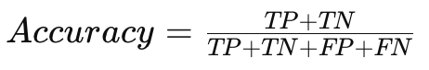
Accuracy
Measures the overall correctness of predictions made by the model.

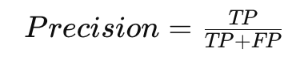
Precision
Measures how many predicted defaulters are actually defaulters.

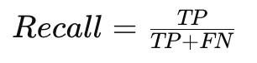
Recall
Measures how many actual defaulters are correctly identified.

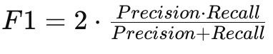
F1-Score
Provides a balance between precision and recall.

ROC-AUC Curve
Shows model performance across different classification thresholds.

Visualization Plots
- Heatmap → To analyze correlation between features
- Histogram → To understand data distribution
- Boxplot → To detect outliers

Required Topics from the Subject
Strings
Used for handling categorical features such as loan purpose and employment type.
File Handling
Used to read dataset files and store processed outputs.

Platform Required
Jupyter Notebook

Books and References
Python for Data Analysis – Wes McKinney
Introduction to Machine Learning – Ethem Alpaydin
https://www.kaggle.com
https://scikit-learn.org

